Obelisk_of_Theodosius 0,0,0 ground point 0,0,25.6

Walled Obelisk 73.76,0,0, peak 73.76,0,0, 32

Right most minar at peak 0, 64.8, 64

Second from the right at peak 0,119.7,64

Third from the right minar at ground at peak = -61.16,70.4,64

Second dome from the left at peak -61.16, 125.31,64

Left peak = -61.16, 175.21,64

I then made the A matrix and from it got the P matrix. Then I took it’s null and got the center of the camera coordinates.

Center =

-244.0376

-100.7609

16.2635

1.0000

I then went back to google earth and used the scale feature again to get to the point.

This is going back in the -x direction.

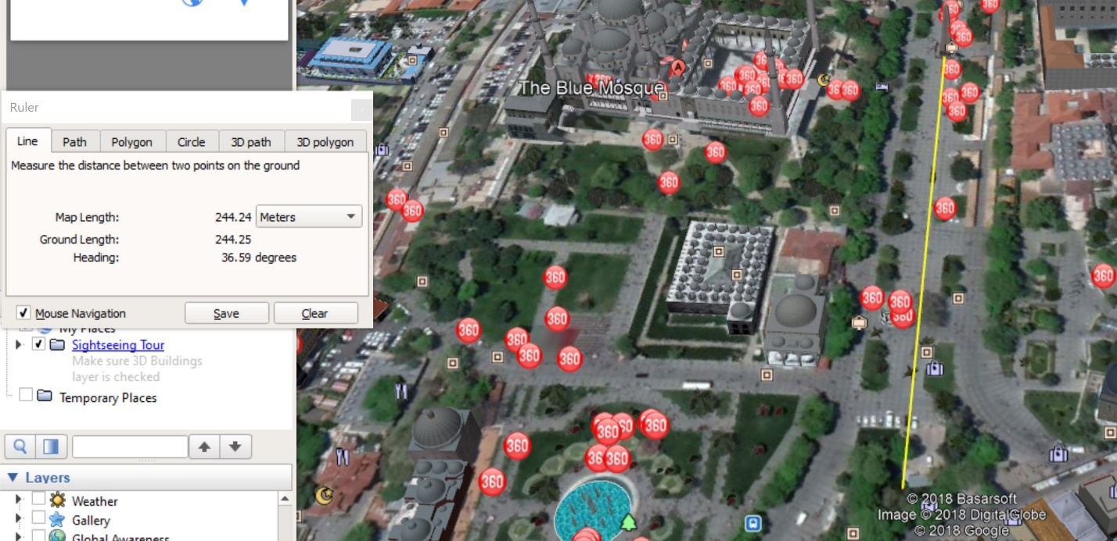

This going back into the -y direction:

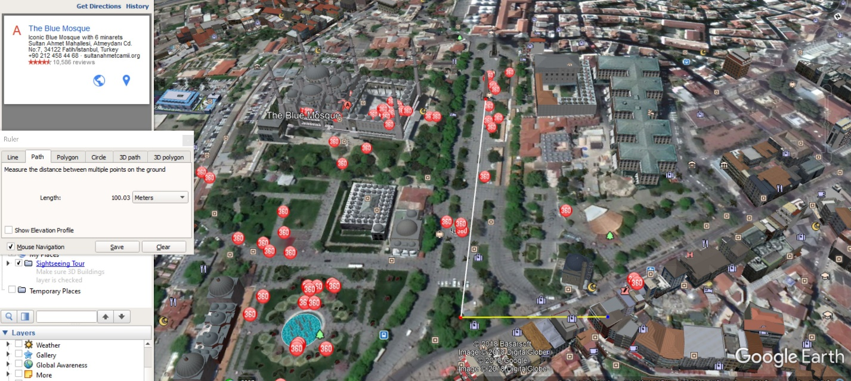

Then I finally found the point and drew the triangle to represent the viewpoint of the artist.

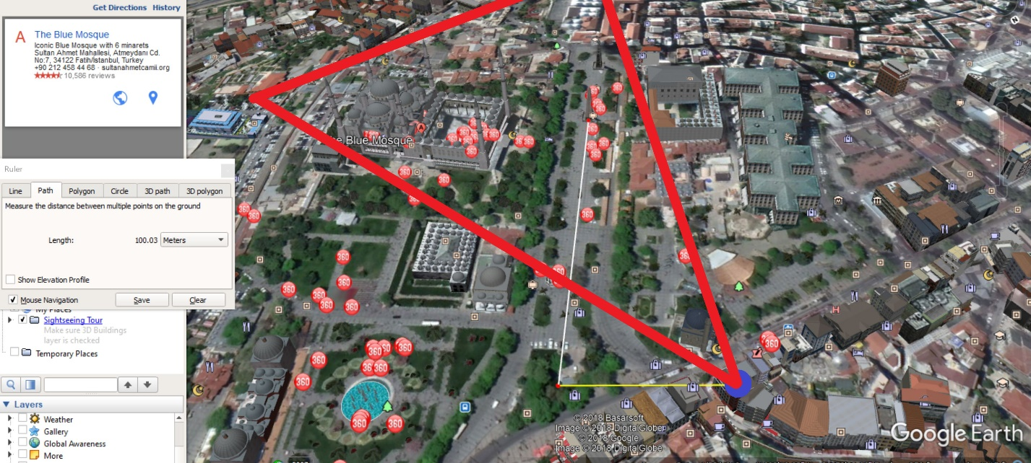

I also then went into 3D view to see the perspective form the point and looked something like this: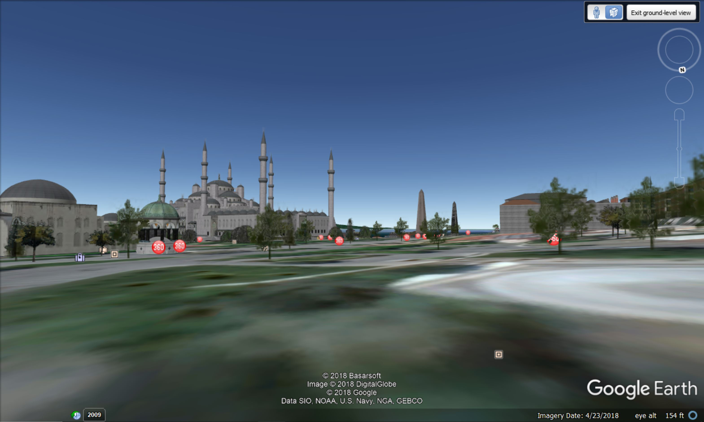

This is zoomed, but it is very close to the original point from where the artist drew the sketch.

Oh this is the code I used : 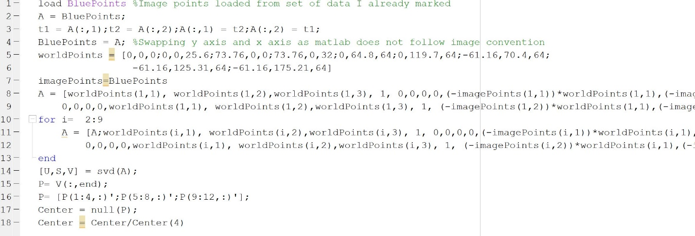

Which is very similar to the one in the last question.